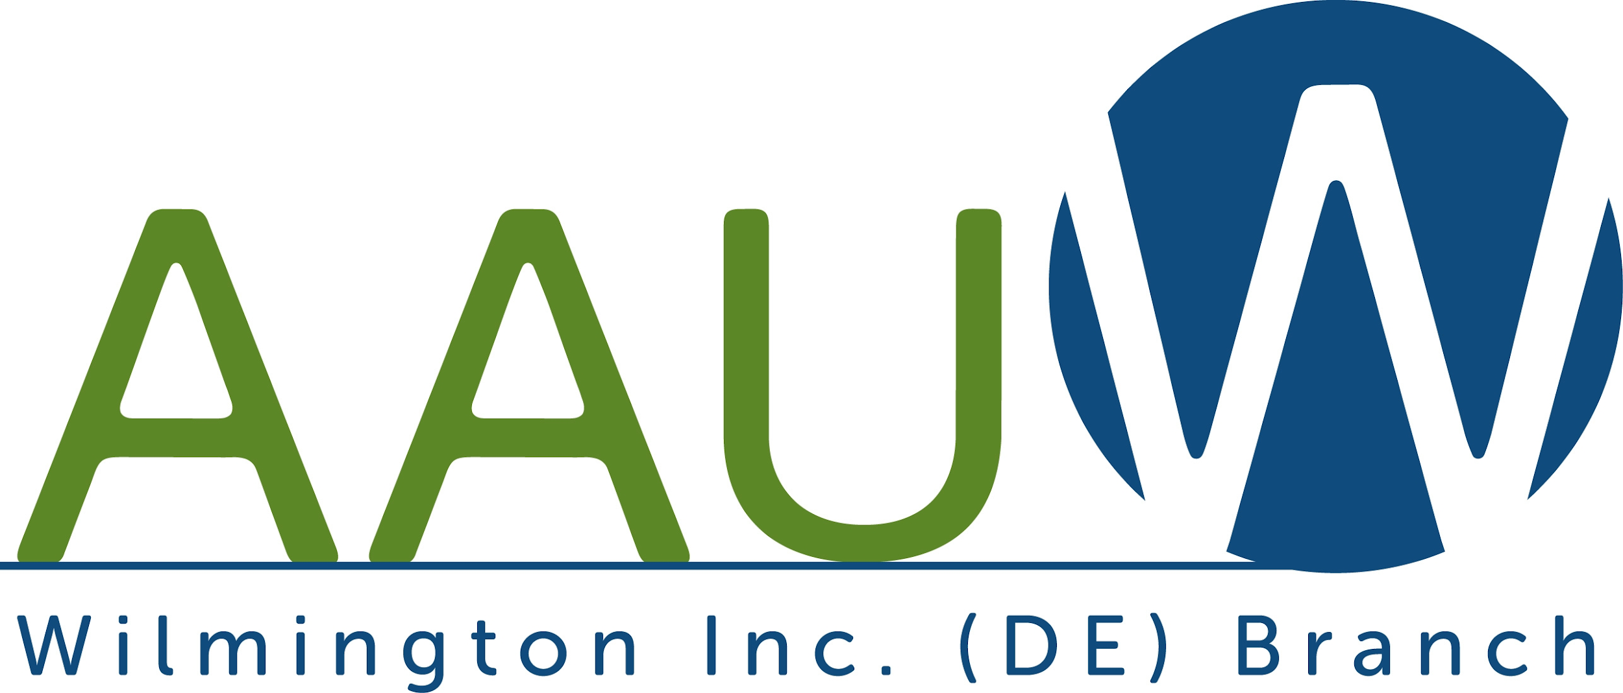

The Wilmington, DE Branch of the American Association of University Women (AAUW) awarded its first scholarship for women to attend college and pursue a baccalaureate degree in 1914 and has continued this tradition for over 100 years. We awarded scholarships to 33 women who are residents of New Castle County for the 2020-2021 academic year. The awards totaled $100,000, with a range of $2,500 to $4,000 per scholar. The scholarships are awarded based on scholastic standing, financial need, contributions to the school and community, and results of standardized testing.

We also select the recipient of the Doberstein scholarship to Wilmington University. The current Doberstein scholar is Jacqueline Cameron.

Our new scholars are the following:

Sofia Alvarez
Oluebube Akujieze
Kayla Bright
Molly Clark
Gwendolyn Clerniak
Brianna Demanczyk
Julia Hurst
Rebekka Kehoe
Jacqueline King
Annalise Maull
Kennedy Medley
Hadley Morgan
Rachael Moten
Dorcas Olatunji
K. Deborah Olatunji
Erin Pyle
Katherine Rippon
Caroline Scalora

We have renewed the scholarships for the following scholars:

Madison Bailey
Christina Bourantas
Raquel Brown
Brooke Cooper
Diana Flores-Caldaza
Tara Grier
Kayla Hurst
Helena Kirk
Naja McCain
Taylor Oden-Randolph
Esther Park
Jessica Price
Rose Reynolds
Kelsey Wiley
Aniyah Wright

The AAUW scholars are graduates of the following high schools in New Castle County: Alexis I. DuPont, Appoquinimink, Archmere, Brandywine, Charter, Christiana, Concord, Design Thinking Academy, Hodgson Vo-Tech, Middletown, MOT, Mt. Pleasant, Newark, Padua, St. Elizabeth’s, Tall Oaks Classical, Tatnall, Tower Hill, Towle Institute, Ursuline, and Wilmington Christian.
Half our scholars selected are STEM majors. Our new scholars’ majors include Architecture, Biological Sciences, Biomedical Engineering, Business, Cognitive Sciences, Communication, Construction Management, Economics, Education (Elementary, Special, and Math), English, Forensic Science, Graphic Design, Health Sciences, Human Services, International Trade, International Studies, Marketing, Neuroscience, Nursing, Nutrition, Political Science, Pre-Professional Physical Therapy, Pre-Veterinarian Medicine, Psychology, Radiological Science, Social Work, and Writing; Counseling (M.S.), Medical School (M.D.) and Veterinary Medicine (D.V.M.).
Almost half our scholars will attend the University of Delaware and one is enrolled at Wesley College in Dover. The other academic institutions include Auburn University, Bucknell University, DePauw University, Duquesne University, Eastern Carolina University, Fashion Institute of Technology, Georgetown University, James Madison University, Manhattanville College, Moravian College, Northeastern University, Rowan University, Temple University, Thomas Jefferson University, University of Georgia, and University of Pennsylvania. 0121

