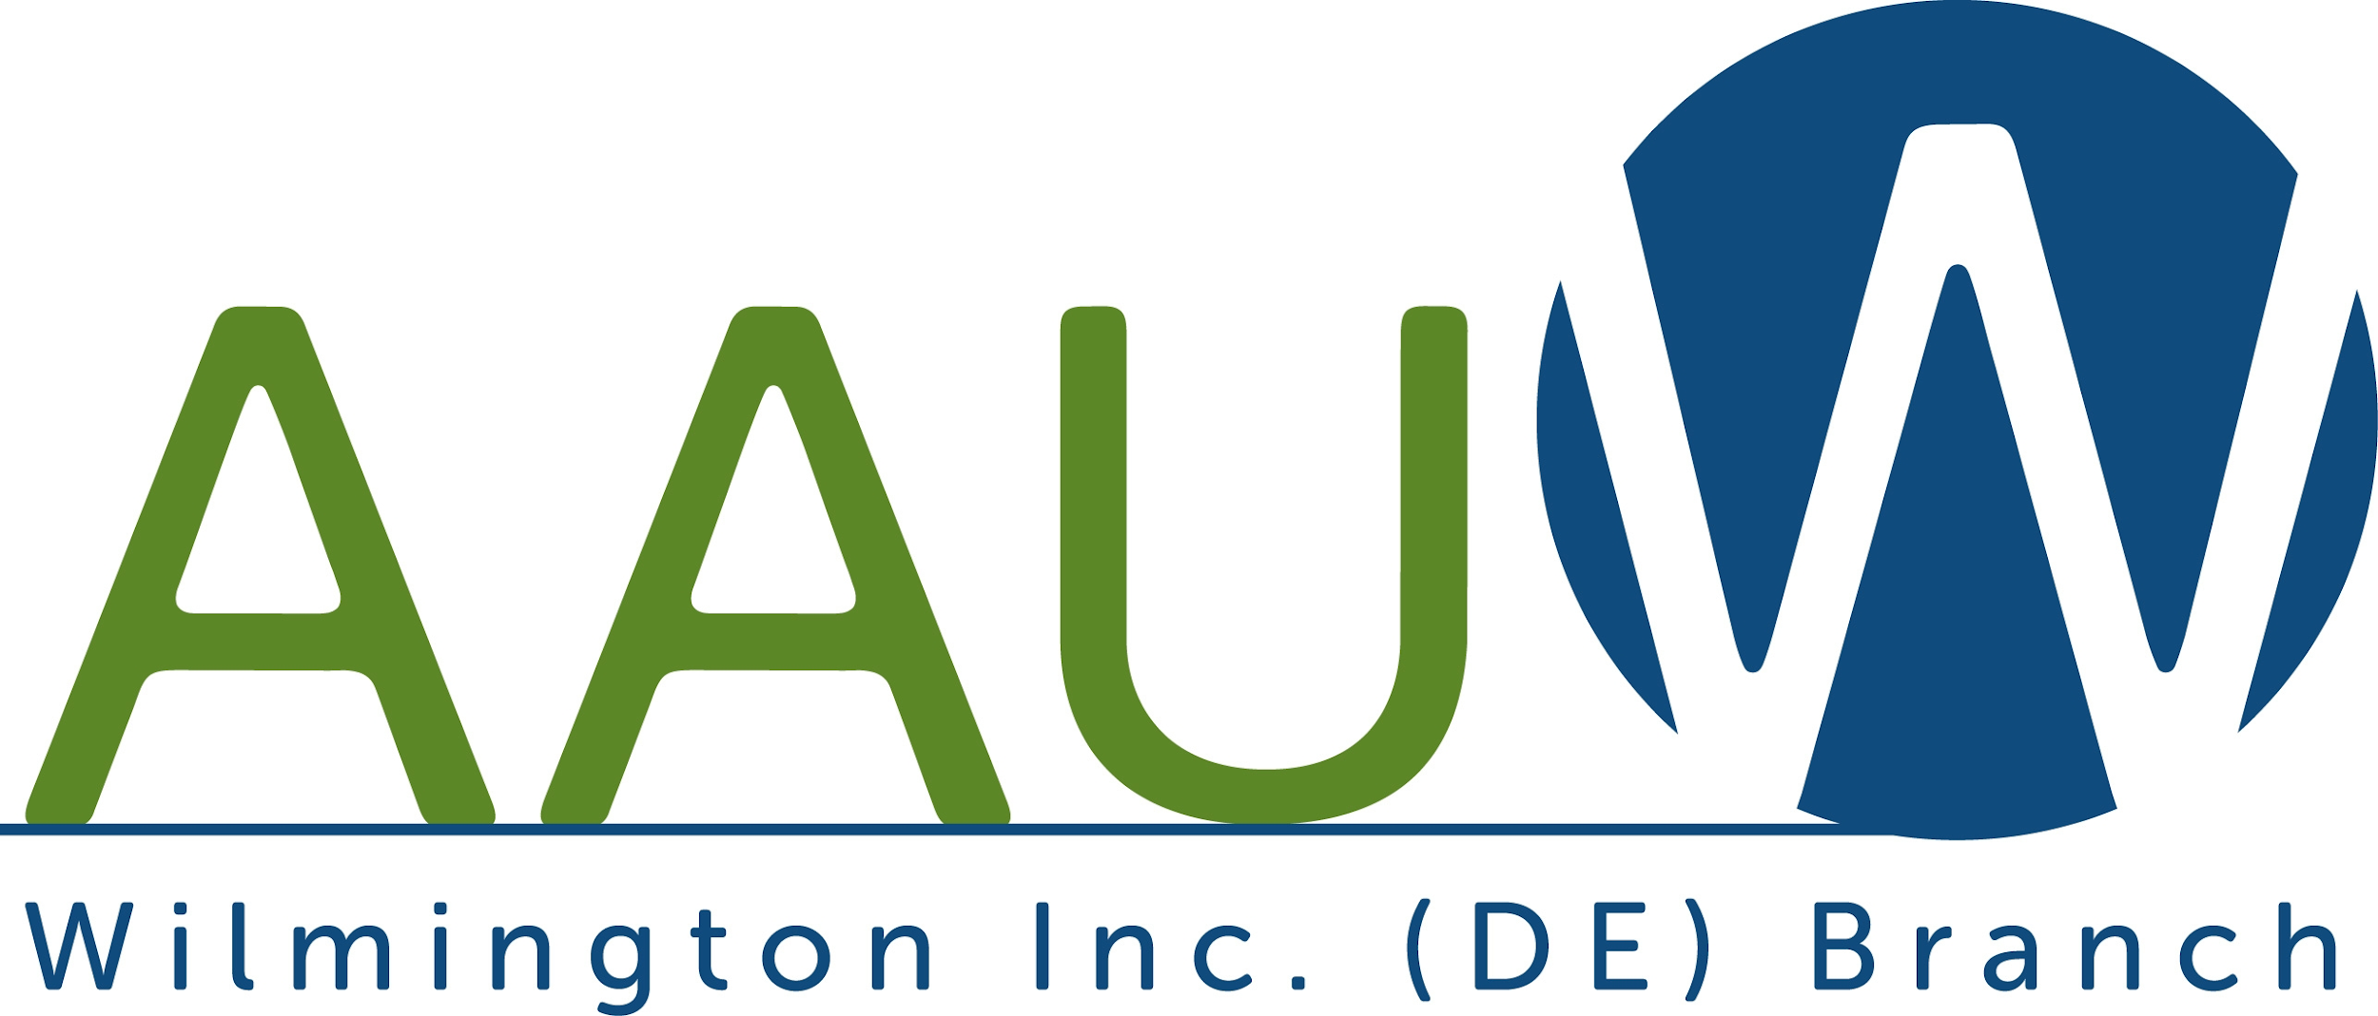

WINNERS ANNOUNCED FOR SCHOLARSHIPS 2023-2024!!!
The Wilmington, DE Branch of the American Association of University Women (AAUW) awarded its first scholarship for women to attend college and pursue a baccalaureate degree in 1914 and has continued this tradition for over 100 years. We awarded scholarships to 17 women who are residents of New Castle County for the 2023-2024 academic year. The awards totaled $100,000. The scholarships are awarded based primarily on financial need, and also consideration of scholastic standing, contributions to the school and community, and results of standardized testing.

We have granted an academic award to the following five scholars:

Jade Balon Smyrna High School
Laurel Clark Middletown High School
Arielle Mahugu Appoquinimink High School
Fanta Saccoh Brandywine High School
Melissa Froemming Returning to school of law several years after graduation from college

We have renewed the academic award for the following twelve scholars:

Oluebube Akujieze
Madison Bailey
Brianna Demanczyk
Tavia Fair
Shams Ibrahim
Rebekka Kehoe
Jacqueline King
Nicole McGhee
Rose Reynolds
Katie Rippon
Mariya Tacheva
Inayzha Wallace

This year’s scholars’ majors are: Criminal Justice and Sociology, Graphic Design, Health Care Management, Health Science, Human Relations Administration, Medical Diagnostics, Medical Laboratory Science, Nursing, Nutrition and Dietetics, Special Education, Doctor of Physical Therapy, Juris Doctor, Doctor of Medicine, and Doctor of Veterinary Medicine.

The students will be attending University of Delaware (7), De Sales University, Drexel University, Drexel University Thomas R. Kline School of Law, Goldey-Beacom College, Immaculata University, Moravian College, Frank H. Netter, M.D. School of Medicine at Quinnipiac University, Sidney Kimmel Medical College at Thomas Jefferson University, University of Georgia Veterinary Medicine, and Widener University.

